Project Title: **Sneaky Shoes E-Commerce**

Group Name: **UNT-DEV**

Team Members List:

* RAHEEM ALI
* GIRISH VARDHAN GAVIREDDY
* SAI KIRAN REDDY SOMA
* LETHASWI THOKALA
* PRATHYUSHA REDDY PIPPIRADA
* LIKHITHA REDDY SAMA
* SAI VENKATARAMA INNAMURI

*The Overall Structure of our E-commerce Website will be*:

* **User Interface**: The user interface is the front-end of the website that users interact with. There are several different pages and features on it, including the main page, product pages, a search bar, a shopping cart, and a checkout page. Customers are able to explore a variety of shoe styles, examine product photos, read descriptions, see product prices, and add items to their shopping carts. To improve user experience, the user interface should be simple to use and visually appealing.
* **Application Server** (Back-end): The back end of a website that manages user requests and data processing is called an application server. It includes the website's business logic, such as the user profiles, shopping cart, and product. To retrieve and save data, the application server talks with the database server. It also contains the Express.js framework, libraries, and JavaScript programming languages that will be utilized to create the website.
* **Payment Gateway**: Either a token-based payment or a third-party service that handles online payments. It should support various payment methods such as credit cards, debit cards, and digital wallets. It also includes fraud detection and prevention mechanisms to protect customers and merchants from fraudulent activities.
* **Admin Users**: Admin users in an e-commerce website have additional privileges and responsibilities compared to regular users. These privileges include:
  1. Product Management: add, edit, or delete products.
  2. Admin users can manage profiles.

Overall, admin user privileges provide greater control and flexibility to manage and optimize an e-commerce website.

* **Includes Directory:** This directory consists of two important things i.e.:

1. Add to cart Feature: In order to store the things that a customer has added to their cart, the "Add to Cart" feature would need building a shopping cart object in the database.
2. Navigation Feature: (SEARCH BOX AND FILTER OPTION)

An eCommerce website's search box and filter options aid consumers in finding the products they're looking for quickly. The search function of the website will then return a list of relevant products once customers enter keywords or phrases connected to the product they are looking for in the search box. This makes it easier for consumers to find what they're looking for even if they're unsure of which category it falls under or if the website has a lot of different products.

* **Index and Error Page:** This index page will contain all the routes for the website. This helps manage the website easily and helps find bugs during the testing phase of the website. The error page, also known as the 404 Page, informs users that there is a problem with the website.
* **Home Page:** This page is the most important page on our website. This page is intended to be user-friendly so that our customers can easily locate their products.

*The below figure shows The Structure of Sneaky Shoes E-Commerce Website.*

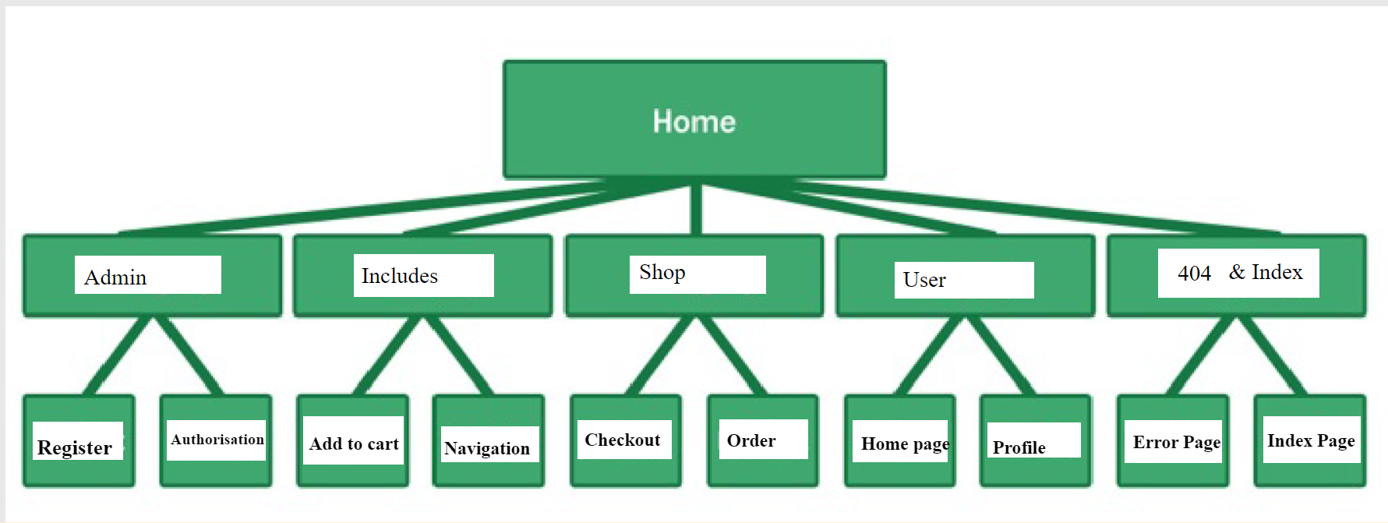

*a. All functional requirements:*

|  |  |  |
| --- | --- | --- |
| **No** | **Function Name** | **Description** |
| 1. | User Login / Log out | User login and logout feature is a standard feature of most websites, including e-commerce websites. It enables users to log in to the website using their credentials, such as a username and password, to access their account and perform various activities. |
| 2. | Buy Option | A popular component of our Sneaky Shoes e-commerce websites is the "Click here to buy" option. It is a call-to-action button that invites customers to buy something by clicking on it. |
| 3. | Search Box | An eCommerce website's search box and filter options aid consumers in finding the products they're looking for quickly.   * The search function of the website will then return a list of relevant products once customers enter keywords or phrases connected to the product they are looking for in the search box. |
| 4. | Add to cart | In order to store the things that a customer has added to their cart, the "Add to Cart" feature would need building a shopping cart object in the database. Information about the product, including the product ID, name, price, and quantity, would be included in the shopping cart object. |
| 5. | Payment Method | Either we integrate third-party service or create our own Token based payment System. This payment system will be secure integrated to our website to purchase any product. |
| 6. | Order Invoice and Email Invoice | A customer's purchase is described in full in an order invoice, which also includes the products they ordered, their prices, quantities, and delivery information. An electronic order invoice that is issued to the customer by email is known as an email invoice. |
| 7. | Email Notification | An automated email will be sent to a consumer to confirm the receipt of their transaction. The order number, date, items ordered, and total amount are frequently included. A consumer will receive an email notification informing them of the status of their order and giving them a record of their transaction. |
| 8. | Filter option | Contrarily, the filter options enable users to specify precise criteria for their search results, such as a particular price range, color, brand, or size. Users can more precisely find what they're looking for by using this to filter their search results. |

*b. All non-functional requirements that are important to system:*

Some of the non-functional needs that are crucial for an e-commerce website include:

* **Performance**: E-commerce websites should be designed to interact fast with the users. This includes aspects like server response speeds, page load times, and the capacity to support User friendly.

Solution: This is why we are using JavaScript as our programming language and MongoDB as our non-Relational Database.

* Security: E-commerce websites deal with sensitive customer information such as payment details, so security is a critical non-functional requirement.

Solution: To handle this we have implemented User login/ Logout with this we will be able to find a valid user.

* Usability: User-friendly navigation should be a priority when designing Sneaky Shoes e-commerce websites. This takes into account factors like succinct and clear product descriptions, simple navigation, and a quick checkout procedure.
* Compatibility: Sneaky Shoes E-commerce websites need to work on a various of browsers and other devices without any problem.

Overall, these non-functional requirements are critical for ensuring that an our Sneaky Shoes e-commerce website will be fast, secure, user-friendly, and accessible to all users.

*c. Interfaces (user, hardware, software, and/or communication):*

Typically, Sneaky Shoes e-commerce website features a number of interfaces that make it easier for the website to interact with users, hardware, software, and communication systems. These are a few illustrations of possible user interfaces for an e-commerce website:

1. **User Interface**: Since customers interact with an e-commerce website to browse products, add items to their shopping carts, and make transactions, the user interface is the interface that is most obvious. The user interface may have a number of components, including filter options, order notifications, shopping cart capabilities, and search functions.
2. **Hardware Interface**: The hardware interface is the connection point between the e-commerce website and the physical hardware used to access the website. This includes devices such as computers and tablets.

In general, only a few hardware requirements are needed for customers to access an e-commerce website. To guarantee a seamless user experience, a device with enough processing power, memory, and an uninterrupted internet connection is essential. To achieve optimum user accessibility, the website should also be made to work with a variety of operating systems and web browsers.

1. **Software Interface**: The software components that are utilized to create and manage the e-commerce website are referred to as the software interface. This covers the website's use of the JavaScript programming languages, MongoDB databases, and React web frameworks.
2. **Communication Interface**: The e-commerce website's connection point to other systems or services with which it interfaces is known as the communication interface. This includes delivery companies, payment gateways, and customer relationship with our Sneaky Shoes website.

In general, the user interfaces of an e-commerce website are essential for facilitating interactions between the website, users, and other systems or services that it interacts with.

*3. The plan for implementing the project through three development phases.*

Here are the three-development phase:

**Phase 1:** (Deadline: 20-Mar-2023)

In this phase Our team plan to do majority of the front-end Development.

This include the prioritize functionalities as follows:

|  |  |  |
| --- | --- | --- |
| S.no | Feature | Priority |
| 1. | User Login | P1 |
| 2. | Search box | P2 |
| 3. | Buy option and product Design (Front-end Only) | P3 High |

**Phase 2:** (Deadline: 10-Apr-2023)

In this phase We plan to connect the front-end and back-end of the website. This face will be the most crucial phase with our website. We have to complete majority of the back-end development.

This include the prioritize functionalities as follows:

|  |  |  |
| --- | --- | --- |
| S.no | Feature | Priority |
| 1. | Buy option and product Design (Back-end Only) | P1 |
| 2. | Add to cart | P2 |
| 3. | Payment option | P3 |
| 4. | Filter option | P4 |

**Phase 3:** (Deadline: 01-May -2023)

In this phase We plan to complete the back-end of the website and Plant to test.

This include the prioritize functionalities as follows:

|  |  |  |
| --- | --- | --- |
| S.no | Features | Priority |
| 1. | Order Invoice and Email Invoice | P1 |
| 2. | Email Notification | P2 |
| 3. | Website Testing | P3 |